Desining professional business cards.

Open Canva and search for Cards to Start your design.

1.Choose a template Choose one of canva’s professionally-desinged card templates. …

2.Personalize your cards fully.Send a cards that’s truly personalized and from the heart. …..

3.Tweak you desingn with more elements . …..

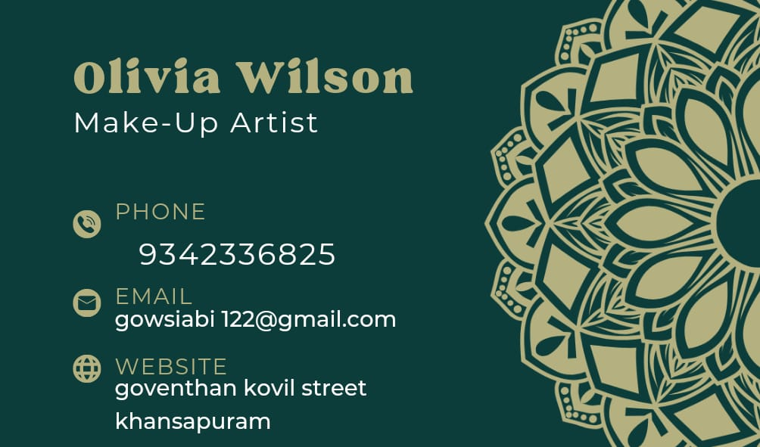

Here’s how to design a business card;

1.Find a template that reflects your brand’s personality.

2.Find the righ typeface.

3.Settle on a size and shape.

4.Organize your information.

5.Do double duty.

6.Maximize your logo.

7.Leave some white space.

8.Add something special.

What Makes a Great Business Card?

.Contact information. Perhaps the most important aspect of any business card is all of the necessary contact information a potential client needs im order to get in touch with you. ….

.Business Name. ……

.Memorable Branding. …..

.Professional Layout and Design. ….

.Personality.

What information Should you not Put on a business card?

1.Splling errors. …..

2.Outdated information ……

3.Low-quality images or videos. ….

4.Unprofessional profiles. ….

5.A home address. …..

6.information not meant for the recipient. …..

7.Going black and white. ……

8.Not list your business clearly. …..